

**UNESCO INTERNATIONAL GEOSCIENCE PROGRAMME (IGCP)**

**Call for Host Institutions**

The United Nations Educational, Scientific and Cultural Organization (UNESCO) Earth Sciences and Geo-hazards Risk Reduction Department is currently developing an international exchange network for young researchers.

The project was approved by the UNESCO Council in 2018 and will establish opportunities for post-graduate (PhD and post-doc) researchers to participate in pre-existing fieldwork projects within the subjects of Earth Sciences (Earth Resources, Geo-Hazards, Climate Change and Hydrogeology).

In the preliminary stages of the project, UNESCO is seeking interest from host institutions that offer local and international fieldwork studies as part of graduate and postgraduate research degrees.

Host institutions will be placed with one or two postgraduate research students from an overseas institution for the duration of a fieldwork project. This will provide an invaluable learning opportunity for young researchers, primarily from developing and least developed countries, and institutions would be involved in the selection process of potential participants.

Institutes that wish to express interest in hosting researchers are invited to write to us with the following information:

1. Details about local or international research fieldwork programmes and field sites, primary subject of the field studies, and academic and professional staff organizing the programmes
2. The approximate dates and duration of the field programme
3. Accommodation, costs and capacity of the field programme

[www.unesco.org/igcp](http://www.unesco.org/igcp)

Contact details: Ozlem Adiyaman Lopes: [O.Adiyaman@unesco.org](mailto:O.Adiyaman@unesco.org)

Marie-Laure Faber:ml.faber@unesco.org

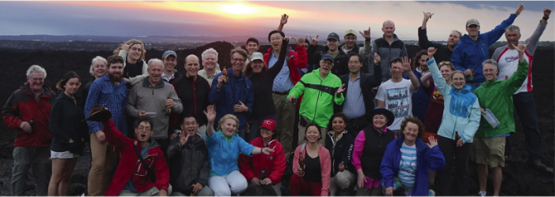

IGCP 648 project meeting in Australia