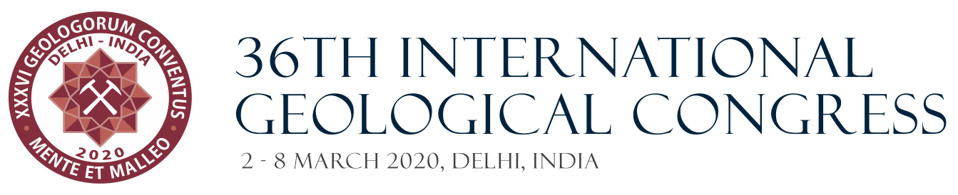

Dear colleagues,

We are pleased to invite you to submit your contributions to the 1.5 Symposium of the 36th IGC on “**Geosciences, Art and Heritage**”, the description of which is given below.

Please carefully read the “Terms and Conditions” and follow the instructions given by the organizers at *https://www.36igc.org/abstract-submission* to submit your abstract/s.

Take into consideration that reception of Abstracts is already open and will close on 31st August, 2019.

**Scope of the 1.5 Symposium – GEOSCIENCES, ART AND HERITAGE**

This Symposium aims to bring together geoscientists, art restorers, curators and artists around their common interest in Geosciences in general and in minerals and rocks in particular, to present, share and discuss their findings, products and proposals.

There is an intense and lasting relationship between Geosciences and Art from ancient stone-made works of art, like the Venus of Willendorf, the paintings in Lascaux Caves or the monuments in GobekliTepe. However, the interaction between Art and Geosciences goes nowadays beyond the material link and it is developing new facets and paths that include:

a) Recognition, description and identification of geomaterials (natural and human-made),

b) Assessment for their preservation and restoration,

c) Use of geoscientific tools in the area or rural and urban archaeology (like remote sensing, geo-radar and archaeomagnetism),

d) Identification of quarries of building rocks in order to replace missing pieces,

e) Identification of rock types and quarries to assess possible forgeries, and

f) Need to identify the mineral composition of pigments to establish their epoch of production and provenance to help Art historians.

Meanwhile, artists and architects make use of geomaterials in new and different ways, not only as materials to work with, but also including local geology and landscape as part of the work of art. This creates new links between geoscientists and artists and opens new areas of interaction such as the conservation of these new works of art in the future.

Geosciences, Art and Heritage are nothing but different and partial approaches to a more complex system and need to link together to produce new and more effective ways of teaching and learning and to build an informed, cultivated and judicious society. Finding and discussing these links is in the spirit of the Symposium and we will be very pleased to receive your contributions and welcome you in India next year.

For any inquire please contact the conveners.

*Dr. José Sellés-Martínez, pepe@gl.fcen.uba.ar*

*Dr. Mónica Álvarez de Buergo, alvarezm@geo.ucm.es*

*Dr. Miguel Gómez-Heras, miguel.gomezheras@uam.es*

*Dr. Tom Heldal*

Conveners